**AP2 Report**

The network design of the circle-in-square supervised neural network for regression consisted of 2 inputs, 5 hidden units, and 2 outputs. The output layer used a softmax function for classification, while the hidden layer transfer function used the default sigmoid. The accuracy and precision of the problem proved to be acceptable, with a train error of 17.53% and a test error of 19.20% for 20 training iterations. I created a dataset with a set of points for two different classes, randomly split the dataset into 75% training and 25% test data sets, and built a feed-forward network using 5 hidden units. Using the PyBrain BackpropTrainer function, I input the training and network dataset in order to create a grid of data points. The training iterations provided a relatively fair estimation of the decision boundary using the data set.

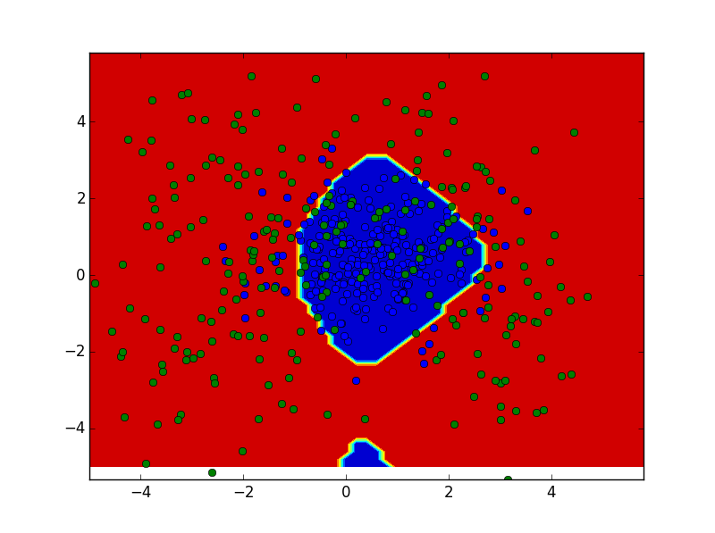

Figure 1

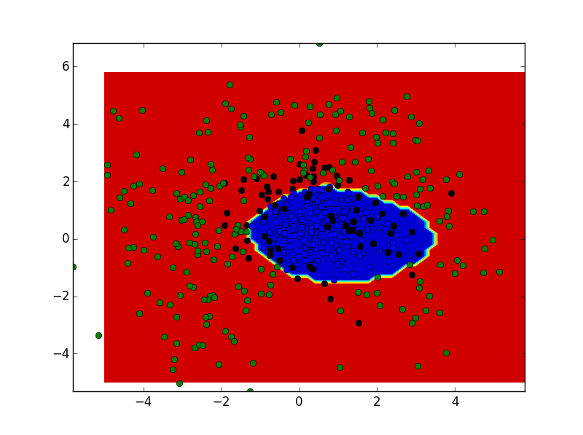

Figure 2